

**BDC5101 Deterministic Operation Research Model**

**Group Assignment**

Topic: Supply chain optimization under trade war

An illustrated example for iPhone XS Max

**Group 12**

|  |  |
| --- | --- |
| Jiang Yi Ching | A0207323R |
| Li Qing Lei | A0165093A |
| Lu Zhi Hao | A0207298W |
| Utkarsh Chaturvedi | A0206518H |
|  |  |

***Professor-in-Charge***: Professor Hu Zhenyu

Abstract

The trade war between China and the US has had negative effects on Apple products. The bestseller of Apple, iPhone, which is mostly assembled in China, is likely to be imposed 15% tariff when it is imported by the US starting from December 2019. US market serves as the principal market for iPhone sales and the failure to maintain its market position would be disastrous to Apple. To mitigate the tariff impact, Apple is considering whether to produce iPhone outside China. In this project, 2-phase optimization models are established to maximize the profit for iPhone sold in the US. To simplify the problem, iPhone XS Max is selected as delegate for iPhone series. Phase 1 model is to minimize Supply Chain Cost once additional tariffs are applied for China to the US. Phase 2 model is to maximize the profit for iPhone sold to consumers there. The results show that China has the least iPhone assembly cost among all nations where such plants (by Foxconn) are available, but the imposition of 15% tariff reverses this affect and could force Apple and manufacturer Foxconn to re-configure their supply chain all the way down to the supplier to optimize their costs, and thus profit.

Key words: Trade war tariff impact, Assignment model, Transportation network model, supply chain optimization

CATALOGUE

1 Research Background and Significance 1

2 Brief introduction of Apple supply chain 1

2.1 Overview 1

2.2 Component Supplier 2

2.3 Assembly plant 2

3 Model design 3

3.1 Prototype model 3

3.1.1 Transportation Network Model 3

3.1.2 Assignment Model 4

3.2 Model overview 4

3.3 Phase one model 7

3.3.1 Objective function and decision variables 7

3.3.2 Constraints 8

3.3.3 Key assumptions 8

3.3.4 Parameter and data source 8

3.4 Phase two model 9

3.4.1 Objective function and decision variables 9

3.4.2 Constraints 9

3.4.3 Key assumptions 9

3.4.4 Parameter and data source 9

4 Empirical analysis 10

4.1 Phase 1 model results and analysis 10

4.2 Phase 2 model results and analysis 11

4.3 Sensitivity analysis 12

5 Conclusions 12

5.1 Suggestions 12

5.2 Research Outlook 12

Reference 14

Appendix 15

Appendix I: Code for Optimizing Supply Chain Cost under Trade-war 15

Appendix II: Iphone Sales figure summary 18

Appendix III: Logistics Cost Data 21

Appendix IV: Component Cost Data 21

Appendix V: Demand and capacity assumptions 22

1 Research Background and Significance

The trade war between China and US that began in 2018 is gradually increasing the cost of exporting all kinds of goods from China to the United States. The total value of goods exported from China to US in 2017 was worth about $550 billion, and goods are all encompassing, including consumer electronics such as mobile phones, tablets, and laptops. On March 23, 2018, US President Trump announced a 25% tariff on aerospace, ICT, robots and machinery products imported from China, which are worth about $50 billion. The tariff was executed on August 23. On September 24 of the same year, a 10% tariff was imposed on goods worth $200 billion. In 2019, the United States imposed a 15% tariff on the remaining $300 billion of Chinese exports in two phases. From September 1, it imposed a 15% tariff on $112 million of goods, including Apple products of Apple Watch and Watchbands, AirPods, Beats headphones and iMac produced in China. Those products account for nearly 10% of Apple's 2018 sales. 15% tariff on the remaining Chinese exports to be imposed on December 15, 2019 will involve iPhone, which accounted for more than 50% of the Apple's sales in 2018.

Apple has spent decades building one of the world's most sophisticated supply chains. The company designs new products in the United States, but the products sold there are mainly assembled in China and exported to the United States, making Apple one of the most vulnerable companies to be exposed in the China-US trade war. If the 15% tariff is imposed from December 2019, the cost of Apple's cash cow product, the iPhone, will increase significantly. If Apple does not choose to bear this cost resulting in lower net profit margin, the price of iPhones sold in the US market will increase, which is not conducive to Apple's dominant 40% market share. It’s biggest competitors in the US, Samsung and LG do not assemble their mobile phones in China, and allowing them certain degree of immunity to the increased tariffs. If iPhone sales are significantly reduced due to rising price, it will have a significant negative impact on Apple's financial performance.

To hedge the impact of the upcoming tariffs and keep iPhone costs stable, Apple should consider reducing the entire iPhone supply chain cost and re-optimizing the flow of goods in the supply chain from suppliers to assembly plants, and from assembly plants to sales markets. By reviewing the report of the financial media, we found that commercial analysts have more qualitative comments on the tariff impact on Apple products, as well as the countermeasures that should be taken, including the redesign of the supply chain. However, research on how to use quantitative tools to optimize the supply chain under tariff is still insufficient.

2 Brief introduction of Apple supply chain

2.1 Overview

Apple has one of the most powerful supply chains in the world thanks to the contribution of a supply chain specialist, Tim Cook, who is now Apple’s Chief Executive Officer. He is credited for streamlining inefficient areas of Apple’s supply chain and using inventory-tracking mechanisms to reduce its number of suppliers and warehouses. Apple’s CEO believes that when it comes to electronic devices like smartphones, tablets and laptops, inventory would depreciate quickly, almost losing 1% of its net book value each week.

To keep inventories low, Apple designs its products in California and develops an extensive network of suppliers, while leveraging the lower cost of outsourcing assembly to China and other developing countries, which attributes to Apple’s supply chain success.

2.2 Component Supplier

Apple’s use of multiple suppliers for the same component makes its supply chain strategy more complicated than other companies. According to recent research, Apple has 785 third party suppliers in 31 countries worldwide providing components like memory, camera, and battery. About half of the key component suppliers are based in East Asia. And many of Apple's suppliers that sell chips, glass, aluminium casings, cables and circuit boards are more concentrated in China in recent years. The clustering of multiple suppliers allows Apple to make hundreds of millions of devices per year while holding only a few days' worth of inventory, which is critical to company’s free cash flow. Apple has a number of exclusive long-term agreements with its key suppliers and uses diversified supplier to negotiate favourable pricing terms, secure strategic raw materials and guarantee high volumes of production.

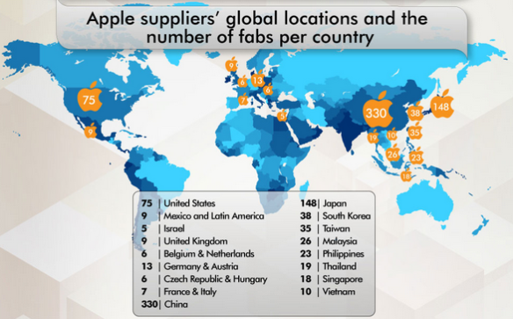

2.3 Assembly plant

Apple’s partner, Foxconn, does most of the assembly for Apple products. More than 50% of the iPhones sold in the global market are now assembled at the Zhengzhou Foxconn plant. Foxconn Zhengzhou plant is located in Zhengzhou Science and Technology Park. By 2018, it had 94 production lines employing 350,000 workers. The component in iPhone comes from more than 200 suppliers and is assembled through 400 processes. The factory has capacity of assembling 50,000 iPhones per day. After the iPhone is produced, it is tested, packaged and shipped directly to the customs supervision area. Here, Foxconn sells the assembled iPhone to Apple at the “assembly price”. Apple resells them to customers around the world. If the iPhone is sold in the US market, air cargo companies would ship iPhone to the major logistics hubs in the United States after customs clearance. After arriving in US, iPhones are distributed to major cities for final sale.

Similar to Chinese market, Apple already has Wistron, another OEM of iPhone, to produce older iPhone models like iPhone SE and iPhone 6s in Bengaluru, India and the manufacturer recently started making the iPhone 7 locally. To satisfy the need in this emerging smartphone market, as well as to serve as an export hub for the Asia Pacific region, Apple intends to cooperate with Foxconn to assemble newer iPhone models locally. Apart from that, Apple will be able to avoid 20% import tax on components, which means newer iPhone models like the iPhone XS Max could become more affordable to Indian customers. To fulfil the need for assembling high-end flagship iPhones, Foxconn plans to initially invest $300 million in 2019 to set things up for Apple in India. The Indian government is currently considering “negligible to null duties” on these imported components which are used to assemble re-exported models. The potential tax incentive would also add feasibility to relocate assembly plant from China to India.

To fully meet the demand of North and South America market in iPhone, Apple plans to utilize Foxconn facilities in Jundiaí, Brazil. However, the strict labour law and influential labour union makes it difficult for Apple to control assembly cost. Brazilian law sets a maximum working hour of 44 hours and annual paid vacation, and labour union negotiates starting wages with Foxconn, that are $550 a month for factory workers there. Compared to wages of similar work in China, it is $515 a month including overtime payment. As a result, Foxconn's factories in Brazil employ only 8,000 workers, which is a fraction of the size of its Chinese counterparts. And most of those workers are building notebooks, printers, and monitors for companies such as Dell and Hewlett Packard. Not until four years ago did Foxconn start to assemble the only Apple product, iPad in Brazil factory,

3 Model design

3.1 Prototype model

3.1.1 Transportation Network Model

General transportation network model is used to optimize the flow in the network to achieve minimum cost. In this optimization problem, the iPhone assembled in factories need to be transported to the sales market where this model could be applied. The model could be formulated as below.

;

3.1.2 Assignment Model

Assignment model is the extension of transport network model, and the difference is that one node in one set can only connect to one node in the other set through one ark. In this optimization problem, every component needs to be assigned to the assembly factory where this model could be applied. The model could be formulated as below.

, ;

3.2 Model overview

The ultimate objective of the model design is to maximize the profit for iPhone sold in the U.S. under trade war tariff. Here, the profit is considered as gross profit (Revenue-Cost of good sold), since we have no access to the operating expenses of Apple and these expenses are difficult to allocate among products.

Transportation network model and assignment model are used as prototype to the optimization of Apple's supply chain under the China-US trade war, and empirical analysis is provided to assess the impact of trade war tariff on Apple supply chain and to optimize its reaction. Since iPhones’ accounts for more than 50% of Apple's sales in 2018, we have developed the optimization models based on this product line. Due to the limitation of this optimization model and difficulty in optimize two iPhone model supply chain simultaneously, we choose iPhone XS Max as the target product.

The supply chain of iPhone XS Max could be simplified as Component Supplier – Assembly Plant – Sales market.

**Assumptions for the supply chain:**

* Component Suppliers: 16 suppliers supply 8 components to 3 factories. There are 16 nodes for “Component Supplier” Set.
* Assembly Plants: 3 Foxconn assembly plants are in China, India, and Brazil separately. There are 3 nodes for “Assembly Plant” Set.
* Sales Market: We only focus on US customers who would be impacted by additional tariffs imposed by US. There is 1 node for “Sales Market” Set.
* Connection between Component Supplier Set and Assembly Plant Set: We assume two suppliers supply one component for maximum 3 factories and there are 8 components required for assembling an iPhone. Only one supplier supplies one component. There are maximum 24 arcs when each of the 8 components is supplied by 1 supplier to 3 factories.
* Connection between Assembly Plant Set and Sales Market Set: There are maximum 3 arcs when all three factories assemble iPhone XS Max and then transport to US market.

Supplier Assembly plant US Market

Component #1

 C:\Documents and Settings\s40712\Local Settings\Temporary Internet Files\Content.IE5\AB9QT5PI\MCj02808020000[1].wmf

Component #1

 C:\Documents and Settings\s40712\Local Settings\Temporary Internet Files\Content.IE5\AB9QT5PI\MCj02808020000[1].wmf 

Component #2

 C:\Documents and Settings\s40712\Local Settings\Temporary Internet Files\Content.IE5\AB9QT5PI\MCj02808020000[1].wmf

Component #n



**Explanation of two-phase model formulation:**

To achieve the goal of optimizing iPhone XS Max supply chain, namely maximizing the gross profit in the market (US market in this case), we consider the subjects that calculate profit, the revenue and cost of good sold. The revenue is a parameter as long as Apple has set the sales price. The cost of good sold, or COGS is what we need to optimize. COGS consist of the cost of raw materials, assembly costs, logistics costs and tariff if applied.

Phase 1 model is concerned with Component Supplier – Assembly Plant process. To minimize the supply chain cost of iPhone, each cost occurred before transportation to US market is considered and optimized. Costs consist of component landed cost at 3 assembly plants (i.e. China, India and Brazil), assembly cost for 3 factories, and the duty cost when applicable.

Phase 2 model is concerned with Assembly Plant – Sales market process. The key decision is to make “minus objects” as small as possible to maximize the profit. One of the objects originated from phase 1 result, which is the product cost of iPhone after assembly.

*Why was a 2 step approach considered?*

* Price of assembling an iPhone and the number of iPhones that can be shipped from a plant is endogenous to each other. i.e. the cost of assembling an iPhone in a plant will decide how many of the phones are exported from the plant and vice versa, the quantity that will be exported will decide how the suppliers (& corresponding costs are distributed)

A very brief example is provided below:

**Normal scenario (Cost of assembling 1 product):**

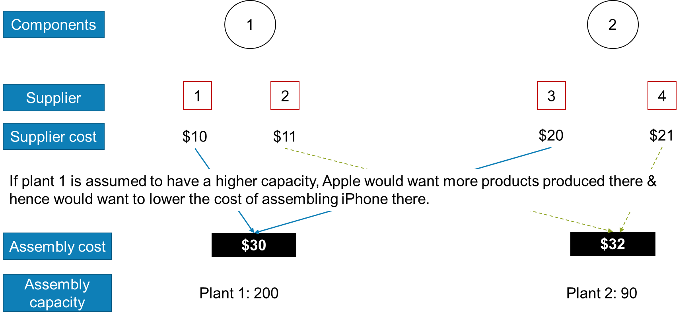

Now, let us assume plant 1 has 10% tariffs imposed on it. Then, the cost of producing the product in plant 1 has become $33. The current supply chain could no longer be optimized.

**Tariff scenario – 10% on plant 1 (Cost of assembling 1 product):**

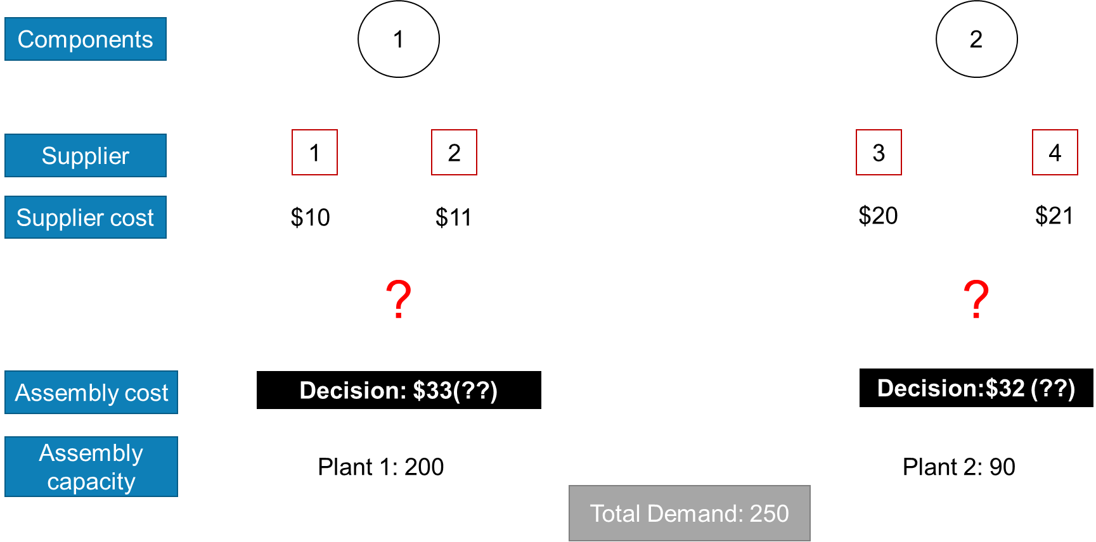

1. *Should Apple continue with Suppliers 1 & 3 for 1st plant & others for the 2nd plant?*
2. *What is the sweet spot of (#products * cost of assembly) to minimize the entire supply chain?*

* **The cost of assembly of iPhone is unknown here**. Assembly cost was different for each plant before the tariff and after the tariff with the inclusion of difference in labour costs, logistics and such and hence, it was important to get cost of assembly. This is the reason that a minimum cost flow problem is not being employed directly in this project.

3.3 Phase one model

3.3.1 Objective function and decision variables

i=1,216 (Suppliers) j=1,2,3 (Plants) k=1,28 (Components)

j=1, China; j=2, India; j=3 Brazil

Decision Variables:, where component *k* is shipped from supplier *i* to plant *j*

Explanation:

Minimize Supply Chain Cost once additional tariffs applied for CN to US.

3.3.2 Constraints

Constraint definitions:

Constraint #1: Only one supplier supplies one component to one plant

Constraint #2: Maximum one component is supplied from one supplier to one plant

Constraint #3: Each component can be supplied by one supplier to maximum of three assembly plants

3.3.3 Key assumptions

(1) There are eight components needed to assemble an iPhone XS Max from 16 suppliers.

(2) Each component is sourced from two suppliers with different component landed cost.

(3) Three assembly plants are located in China, India and Brazil

(4) There is 10% Import duty for raw material imported by India Factory

(5) There is 15% Finished Goods Import duty from China to US

(6) Assembly cost is different at 3 factories.

3.3.4 Parameter and data source

In the objective function, there are two parameters, and .

when j=1, =15% of final production cost, represents China to US duty.

Otherwise, =0

is the cost of component k is shipped from supplier i to plant j.

Component landed cost + assembly cost

Component landed cost at 3 assembly plants is collected from the benchmarking team in IHS Markit Company. Assembly cost for three factories is reckoned and adjusted by the assembly cost in *Tech Insights' component cost estimates of IPhone XS Max*. For factory in China, the number is directly cited from the article. For Indian and Brazil factory, the assembly cost is correspondingly adjusted by the minimum wage proportionally, meaning that the assembly cost in India and Brazil is calculated by the minimum wage in China times coefficient (minimum wage in India or Brazil/minimum wage in China). The minimum wage stands for the worker’s minimum wage in Foxconn, which is collected from HR department of Foxconn.

3.4 Phase two model

3.4.1 Objective function and decision variables

j=1,2,3 (Factories: j=1, China; j=2, India; j=3 Brazil)

Decision variables: , quantity shipped from plant j to US market

Explanation: Maximize the profit for iPhone sell in US.

Profit = (Retail PriceQuantity)–Sum [1.15(Production cost of China Quantity from China) + Logistics Cost from China + (Production cost elsewhere Quantity from elsewhere) + Logistics Cost from elsewhere]

3.4.2 Constraints

Constrain definitions:

Constraint #1: Sum of iPhones shipped from all plants is less than or equal to demand

Constraint #2: Each plant produces iPhones less or equal to its capacity

3.4.3 Key assumptions

(1) Optimized production cost () is from Phase 1 model result

(2) Average Customer demand equals to 1145 thousand units per month (Refer to 3.4.4 demand section for detail)

(3) Factory capacity in thousand units per month (Refer to 3.4.4 section for detail)

• China: 800

• India: 360

• Brazil: 120

(4) Retail price of iPhone XS Max: $1000, which is the selling price of 64GB series in 2018.

(5) Logistics cost/unit from 3 factories to US marker: China $2.9, India $3.3, Brazil $1.8

3.4.4 Parameter and data source

(1) derived from phase 1 model result, which becomes a parameter.

(2) =15% when j=1, otherwise 0.

(3) is logistics cost from factory j to US market, which is collected from internal database of a logistics company.

(4) is the capacity in factory j. The capacity of factory is matched with sales since Apple does not adopt policy of holding inventories. Based on *Apple 2018 Q1-Q4 Unaudited Summary data*, the average monthly iPhone sales in America is calculated. With further information on the percentage of market share of iPhone XS Max, iPhone XS Max sales number (in units) is obtained. We assume that China, India and Brazil factory accounts for 60%, 30%, 10% of the capacity, and the proportion could be altered in sensitivity analysis. Finally the capacity is adjusted up to the nearest whole number to allow buffer capacity.

(5) Demand is the average customer demand for iPhone XS Max in US market. The demand is reckoned from monthly sales of iPhone XS Max that is explained before.

4 Empirical analysis

4.1 Phase 1 model results and analysis

Phase 1 model is to minimize Supply Chain Cost once additional tariffs applied for CN to US. The result shows the optimized plan for supplying components to the factory, which is summarized below.

Selected arcs:

Solution format: Supplier i chosen-factory j for assembly, for component k: Component cost

Supplier 1- factory 1 for component 1: Component cost 71.5

Supplier 1- factory 3 for component 1: Component cost 72.1

Supplier 2- factory 2 for component 1: Component cost 71.7

Supplier 3- factory 2 for component 2: Component cost 22.85

Supplier 3- factory 3 for component 2: Component cost 22.45

Supplier 4- factory 1 for component 2: Component cost 22.85

Supplier 5- factory 1 for component 3: Component cost 17.6

Supplier 6- factory 2 for component 3: Component cost 17.6

Supplier 6- factory 3 for component 3: Component cost 17.2

Supplier 7- factory 2 for component 4: Component cost 41.35

Supplier 8- factory 1 for component 4: Component cost 41.35

Supplier 8- factory 3 for component 4: Component cost 40.95

Supplier 9- factory 1 for component 5: Component cost 120.2

Supplier 9- factory 3 for component 5: Component cost 120.6

Supplier 10- factory 2 for component 5: Component cost 120.2

Supplier 11- factory 2 for component 6: Component cost 37.8

Supplier 11- factory 3 for component 6: Component cost 38.2

Supplier 12- factory 1 for component 6: Component cost 37.8

Supplier 13- factory 2 for component 7: Component cost 6.7

Supplier 13- factory 3 for component 7: Component cost 6.7

Supplier 14- factory 1 for component 7: Component cost 6.5

Supplier 15- factory 1 for component 8: Component cost 30.6

Supplier 15- factory 2 for component 8: Component cost 30.6

Supplier 16- factory 3 for component 8: Component cost 30.2

Optimized Factory CN/IN/BR production cost, without considering CN-US duty:

[372.9, 395.68, 374.9]

Optimized Factory CN/IN/BR production cost, after considering CN-US duty:

[428.835, 395.68, 374.9]

The production cost in China is increased due to the tariff and is higher than the production cost in India and Brazil. However, India and Brazil factory have generally higher production costs than China factory if there is no tariff ($372.9 vs 395.68, 374.9). Overall, the supply chain cost would increase even if Apple had taken action.

4.2 Phase 2 model results and analysis

We setup Benchmark model in Groubi to simulate if there is no CN to US tariffs, the optimize gross profit is $709,386,000 with below optimized allocation plans per month:

China factory: 800’ k units

India factory: 225’ k units

Brazil factory: 120’ k units

When CN to US tariffs applied, there are 2 scenarios Apple could follow.

Scenario 1:

Apple still produces same number of iPhones in China (800’k units/month) and does NOT pass the 15% tariff go consumers

Profit = $709,386,000 – 800,000*$372.9*15% = $664,638,000

Monthly profit variance vs Benchmark profit =$664,638,000 - $709,386,000 = -$44,748,000

Scenario 2:

Apple transferred some capacity to India and Brazil based on the optimize result from phase 2 model. Phase 2 model is to maximize the profit for iPhone sell in US consider the CN to US tariffs rate of 15%. The optimized gross profit shows $669,059,000 for monthly iPhone XS max sales in US market, with below allocation plans:

China factory: 665’k units

India factory: 360’k units

Brazil factory: 120’k units

Monthly profit variance vs Benchmark profit =$ 669,059,000 - $709,386,000 = -$40,327,000

Monthly Loss Deduction from Scenario 2 vs Scenario 1: $4,421,000

From this analysis, in order to maximize the profit, Apple should follow the model’s optimized solution to transfer some of the capacity outside China to hedge the negative impact of tariff although loss still occurs.

4.3 Sensitivity analysis

For the sensitivity analysis, we consider the parameter that would impact the optimization model if the number were changed. Some costs only account for a small portion of the total cost, and they are excluded from sensitivity analysis. For example, logistics cost from supplier to assembly plants is relatively small of the total supply chain cost, and it’s chane would not have large effects.

Also we exclude some parameters that are not subject to a significant change. For example, in phase 1, some arcs do not exist in the initial settings because the supplier is not able to produce certain component and transport it to the factory. Likewise, there is remote possibility that it could make this component in the near future. We still maintain a big M (i.e. 10000) in the cost matrix like phase 1 formulation. Component landed cost and assembly cost in finished good cost is comparatively stable as long as the manufacturing process remains the same and no significant technology improvement occurs to obtain lower cost.

The parameter covered in sensitivity analysis is the factory capacity in Phase 2 model. Initially we set the factory capacity as a parameter to solve the model. And the percentage allocated for China, India and Brazil is 60% (800 thousand units per month), 30% (360), 10% (120). The allocation simulates the real case in Apple’s supply chain. Now we assume the capacity allocated to China factory is decreased by 50, 100, 150 with interval of 50 thousand units per month and allocate the capacity to India or Brazil factory.

**The result shows that after transferring 300 thousand units per month to India factory, the optimized quantity shipped from India to US market is less than the capacity, meaning that the capacity in China should remain at least 500 to avoid idle line.** For Brazil factory, the optimized quantity shipped from Brazil to US market is less than the capacity only after transferring 100, meaning Apple should not transfer too much capacity for Brazil to maximize supply chain value.

5 Conclusions

5.1 Suggestions

To summarize, Apple would have fewer losses if some portion of iPhones were assembled outside China to mitigate the impact of trade war tariff. However, to produce iPhone outside China is a strategic decision that needs to be carefully considered in that it requires major investment and takes a few years before the factory is ready for mass production. Besides, the factory outside China must comply with generally more stringent law and regulations on environment and labour.

5.2 Research Outlook

In the optimization model, we mainly focused on maximizing gross profit for iPhone. Nevertheless, the cost below gross profit (i.e. factory operating expenses) would become an influencer to the optimization decision, and we did not consider the cost due to the limitation of data source. If the data were available, the model would simulate better on the tariff effect. Moreover, Apple has more than 200 suppliers for iPhone, and we only chose 8 main components to simplify the problem. The project could be extended to more supplier nodes.

Reference

[1] <https://en.wikipedia.org/wiki/Apple_Inc>.

[2]<https://en.wikipedia.org/wiki/Foxconn>

[3] Tech insight cost

<https://www.macrumors.com/2018/09/25/iphone-xs-max-estimated-component-costs/>

[4] XS MAX breakdown of components

<https://benchmarking.ihsmarkit.com/606680/iphone-xs-max-costs-apple-20-more-in-materials-than-last-years-smaller-iphone-x-ihs-markit-teardown-reveals>

[5]<https://www.bloomberg.com/news/articles/2019-08-30/trump-trade-war-with-china-will-hit-apple-for-real-this-weekend>

[6]<https://www.iphoneincanada.ca/news/foxconn-building-5-new-factories-in-brazil-to-meet-apples-manufacturing-demands/>

[7]<https://economictimes.indiatimes.com/tech/hardware/made-in-india-iphone-x-from-july/articleshow/68824180.cms>

[8]<https://en.wikipedia.org/wiki/China%E2%80%93United_States_trade_war#2018>

[9]<https://finance.yahoo.com/news/apple-supply-chain-hon-hai-foxconn-on-semi-qualcomm-145003086.html>

Appendix

Appendix I: Code for Optimizing Supply Chain Cost under Trade-war

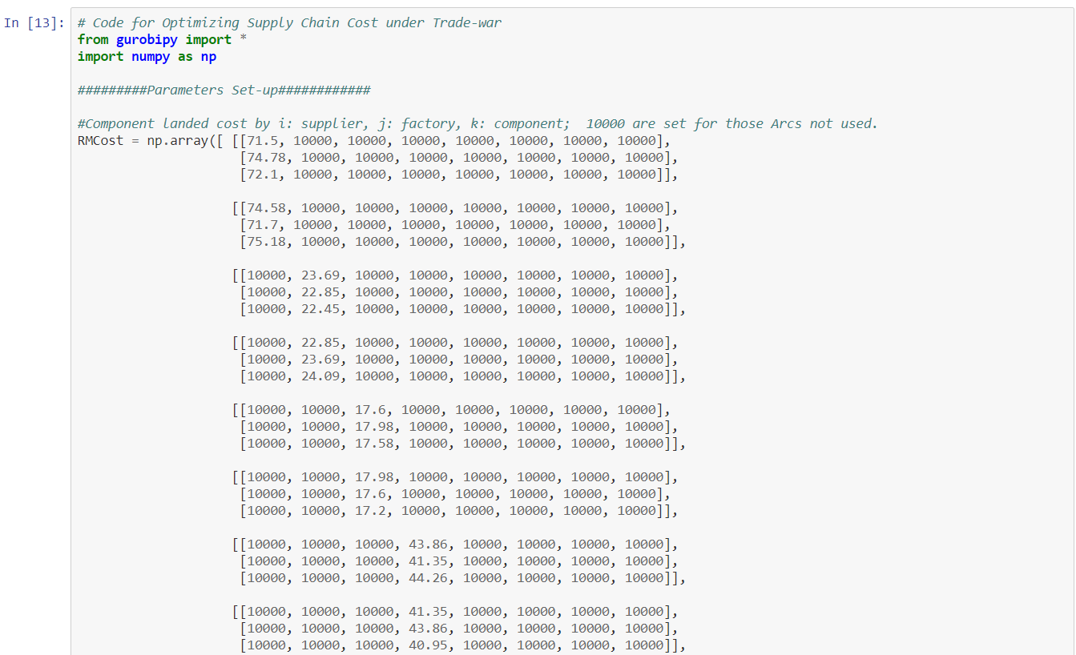

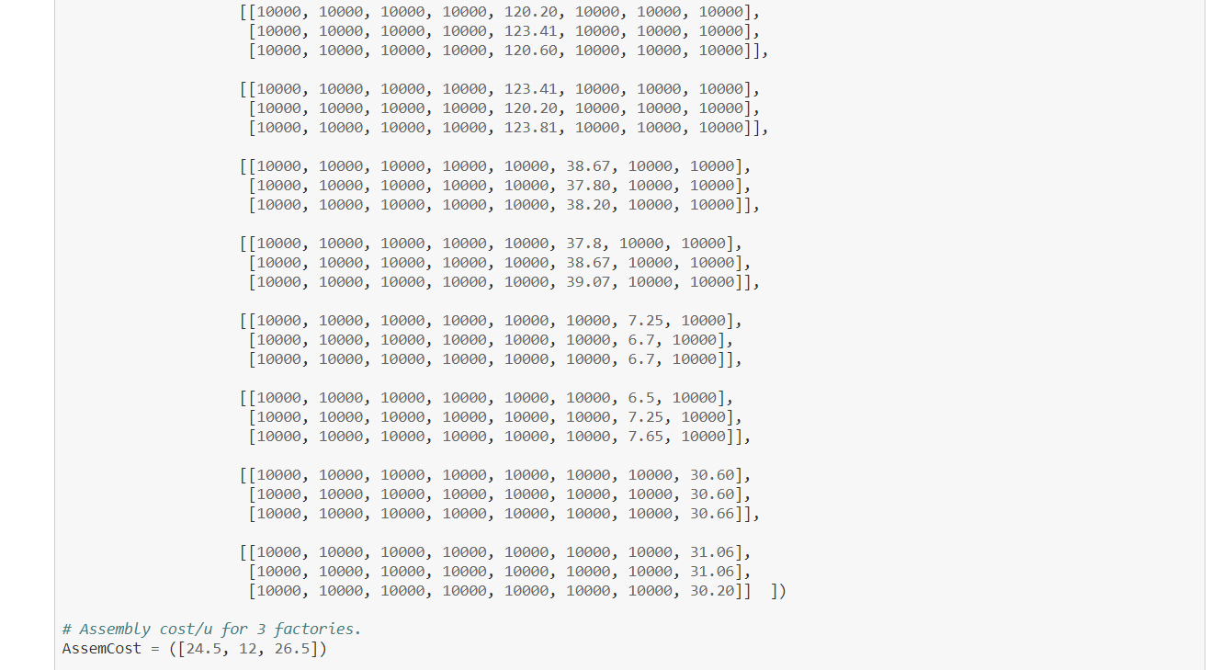

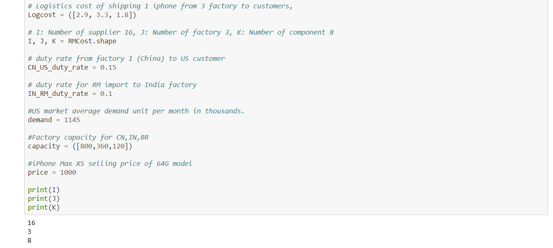

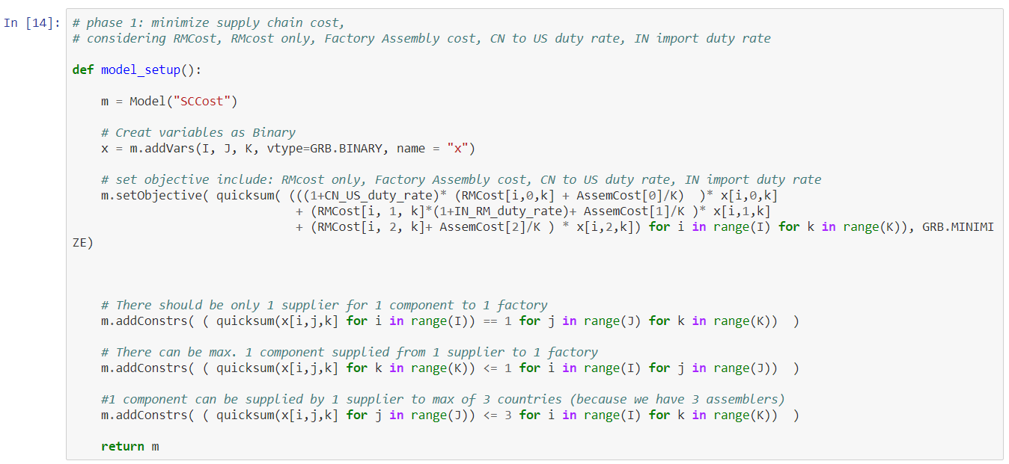

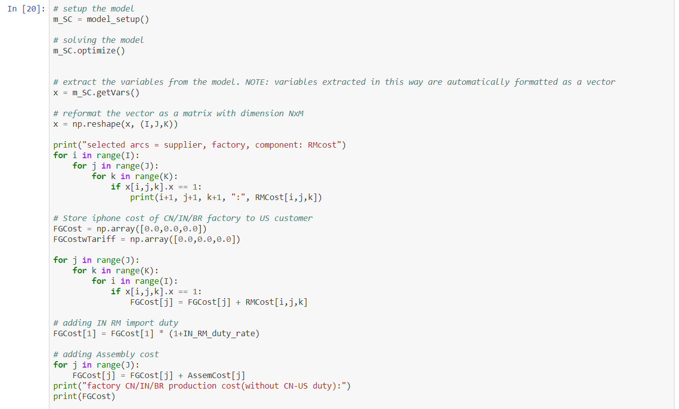

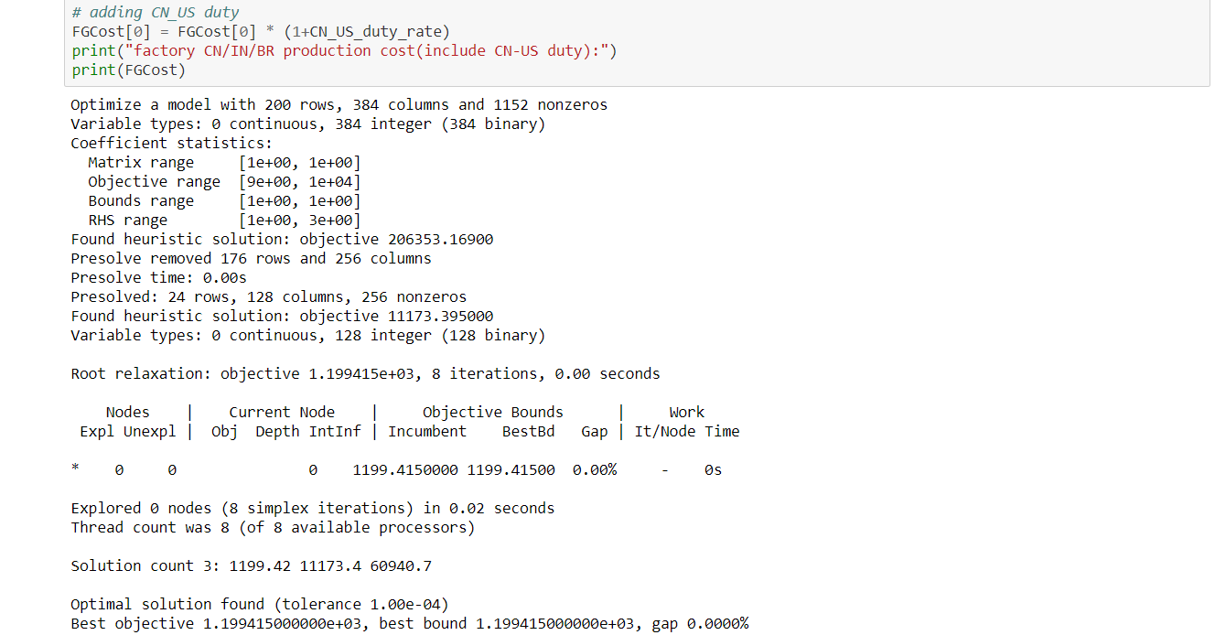

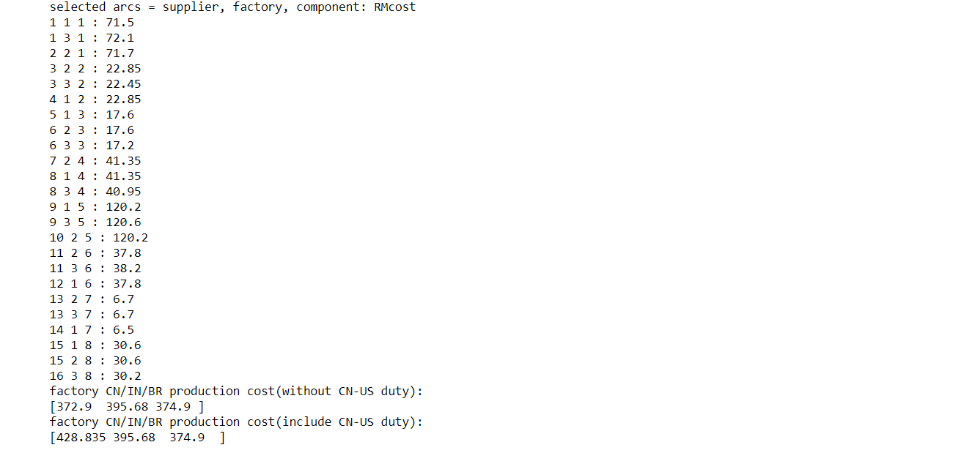

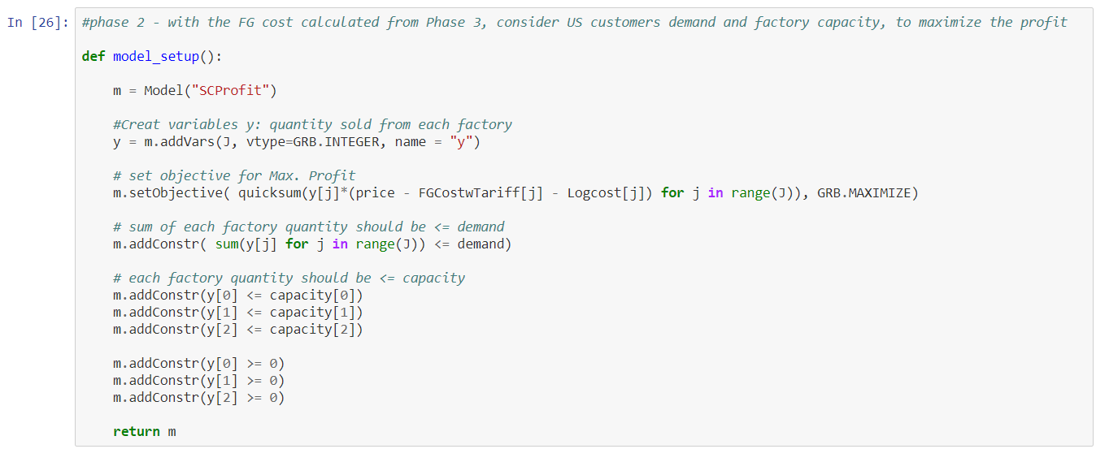

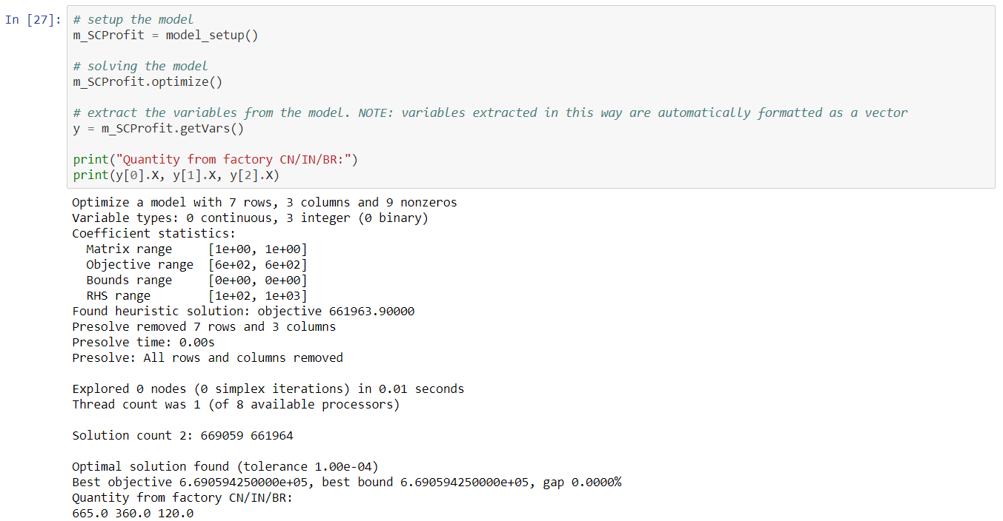

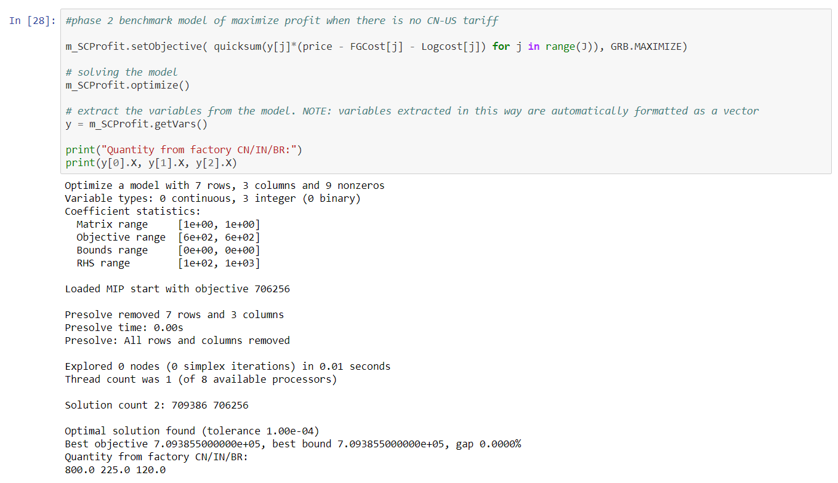

Appendix II: Iphone Sales figure summary









Appendix III: Logistics Cost Data

Raw Material Flow (Suppliers to Factory at China, India, Brazil)



|  |  |  |
| --- | --- | --- |
|  |  |  |
|  |  |  |
| Finished Goods | |  |
| **Origin** | **Dest** | **Rate (US$/kg)** |
| China | US | 2.9 |
| India | US | 3.3 |
| Brazil | US | 1.8 |

Assumptions: iPhone Unit weight with packaging=1kg

Appendix IV: Component Cost Data

General component information



Factory Landed Cost of components assembled in China, India and Brazil originated from Supplier 1 and Supplier 2 (in $)

Appendix V: Demand and capacity assumptions

